How to EFile Warrants

Version 1.1

September 1, 2015

Don Bellenger

[donald.bellenger@gmail.com](mailto:donald.bellenger@gmail.com)

240-426-1589

EFile Warrants – Version 1.1

**Table of Contents**

Introduction 3

Clean out old files from the last run 4

Scan signed warrants to the Z: Drive, and copy the files to the EFile environment 6

Use LTWeb to make an Excel Helper File 9

Step W1 – Rename Signed Warrants from Scanner 14

Connect to EFile Express in the Internet Explorer Web Browser 19

Step W2 – Efile the Named Warrants 21

# Introduction

These step-by-step instructions are written for “Cathy”. Modify for use in your own environment.

This document describes a procedure for EFiling Petitions for Warrant of Restitution to District Court of Prince George’s County (“warrants”), once the forms have been signed by the plaintiff attorney (e.g. Kevin McParland). This EFiling procedure is part of a wider set of set of applications for producing warrants, which includes LTWeb for entering the data for the warrants. That data is entered by BBSG (“Firm”) personnel, or by the Firm’s clients themselves.

There is occasionally a reference in this document to TeamViewer, which is software that enables you to work from home, as if you are sitting at your computer at work. When using TeamViewer, the receipts you produce will print at the office, unless you set up remote printing to print Receipts at home.

There are these steps in EFiling warrants:

* Clean out old files from the last EFile warrants run
* Scan signed warrants to the Z: Drive, and copy those files to the EFile environment
* Use **LTWeb** to make a **Helper Excel file**
* Step W1 - Rename Signed Warrants
* Connect to EFile Express in the Internet Explorer browser
* Step W2 – Efile the Named Warrants

# Clean out old files from the last run

* Use **Windows Explorer**. You can get to Windows Explorer from the “Windows Start Menu” you see when clicking the **Start Button** (shaped like the earth, with a Microsoft flag covering it) on the lower left of your Desktop

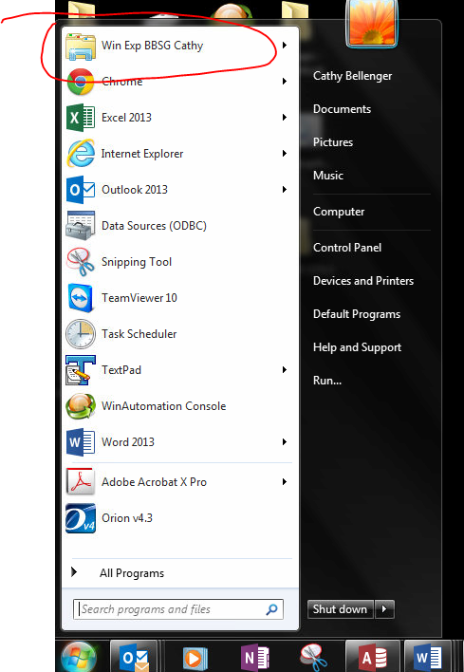

* Delete all the files in these directories
* F:\CATHY EFILE 2\SingleTargetFile
* F:\CATHY EFILE 2\Step W1 – Signed Warrants
* F:\CATHY EFILE 2\Step W1 Backup – Signed Warrants That Were Renamed
* F:\CATHY EFILE 2\Step W2 – Named Warrants
* F:\CATHY EFILE 2\Step W3 – Warrants That Were EFiled

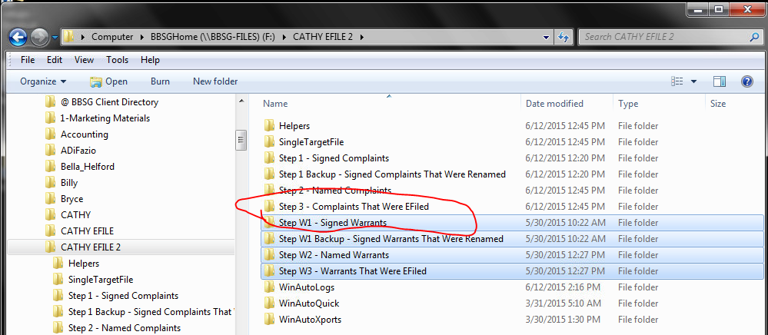

# Scan signed warrants to the Z: Drive, and copy the files to the EFile environment

* Scan each signed Warrant into Z:\cathy
* Remember the date and time when you did the scan
* Go to Z:\cathy in Windows Explorer
* IF you don’t see the “Date Modified” column, click the icon way to the right of “New Folder”, and select “Detail”

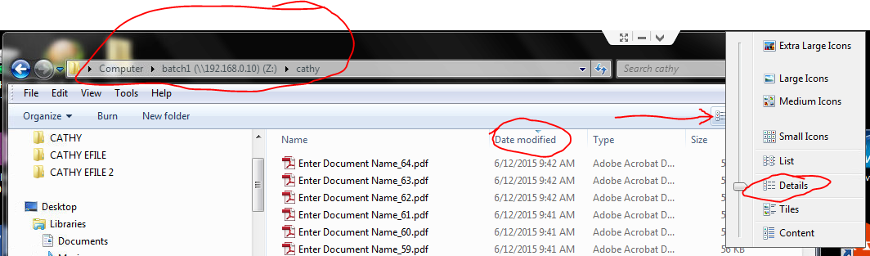

* Select the warrant files for one property. **You can only EFile for one property at a time**. You can look at Date Modified to see if you have the right files. To select the group of files to copy:
* EITHER use the mouse and shift key
* OR click on the first file, hold the shift key, and hit the down arrow until you get to the last file

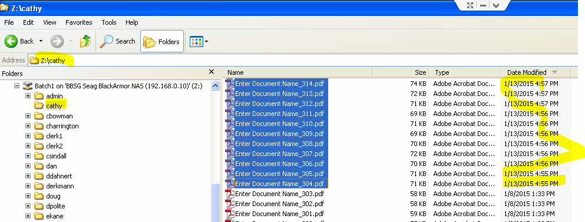

* Press ctrl-C to copy the files.
* Navigate to F:\CATHY EFILE 2\Step W1 – Signed Warrants
* Press ctrl-V to paste the files.
* Right-click on the **F:\CATHY EFILE 2\ Step W1 – Signed Warrants folder**, select Properties, and note the number of files. For example, in the picture below, there are 11 Warrants to EFile. ** Remember that the Warrants procedure is similar to the Complaints Procedure, but uses different directories. Don’t confuse F:\CATHY EFILE 2\ Step W1 – Signed Warrants folder with the similar directory used for Complaints.

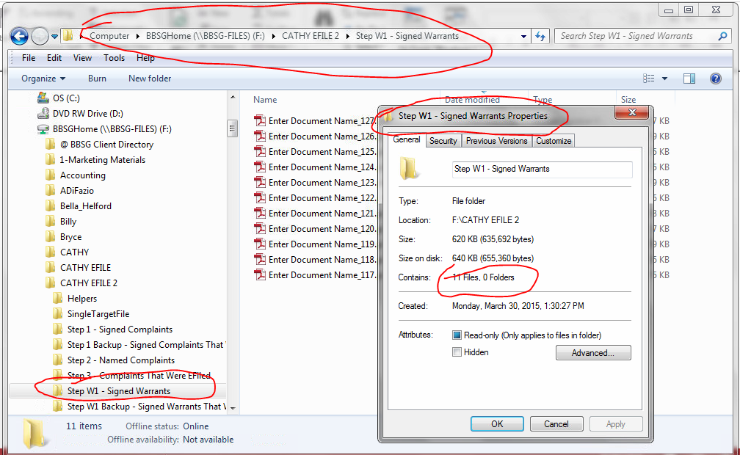

# Use LTWeb to make an Excel Helper File

* Go to the Chrome browser
* Start the LTWeb application, and log in 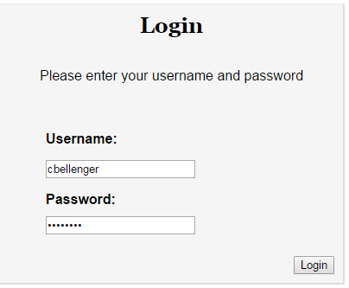
* Select the correct Client, Property, and Filing to match the set of warrants you are EFiling. Start with client, search, and click on the record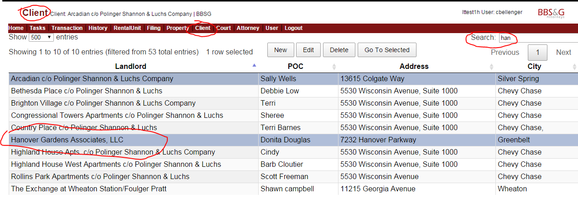

Select property, and click on the property

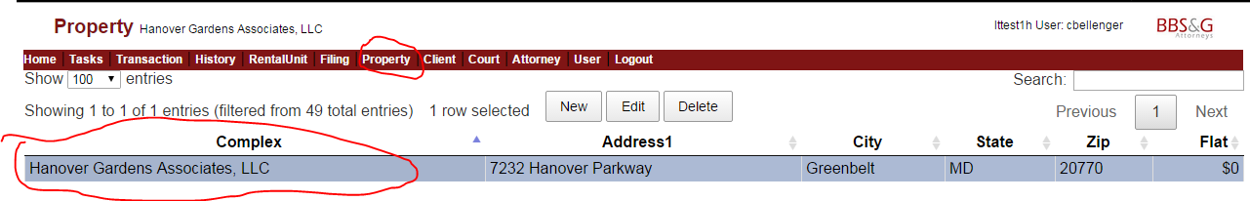

Select Filing, and click on the Filing with the warrants

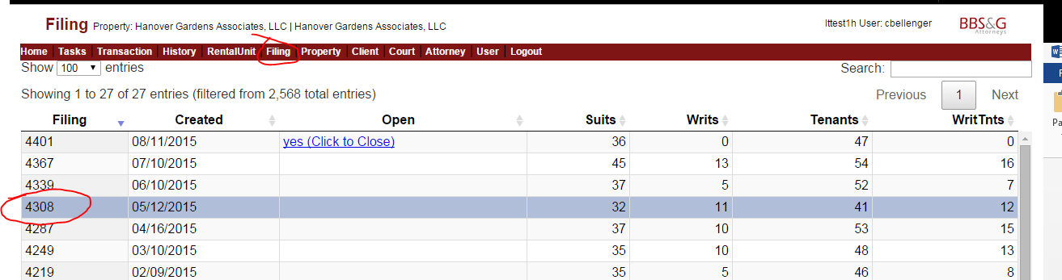

Select Tasks, and click Calculate Absolutes, and then Calculate Filing Statistics, and then Make Excel Helper for EFiling Warrants.

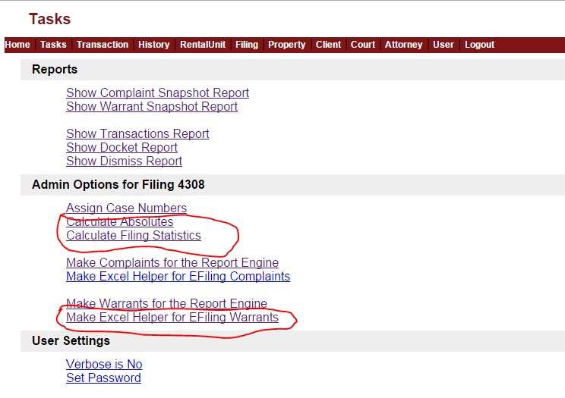

LTWeb will make a Destination File Name for the Excel Helper file, based on the date and time the file was generated, the Client, and the Filing. Just accept it, and click Go.

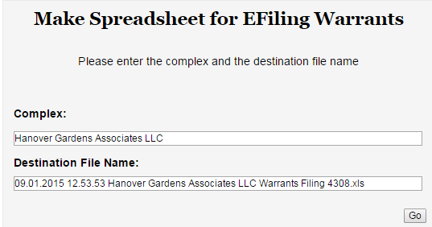

The Excel file will be downloaded to your Browser’s download area.

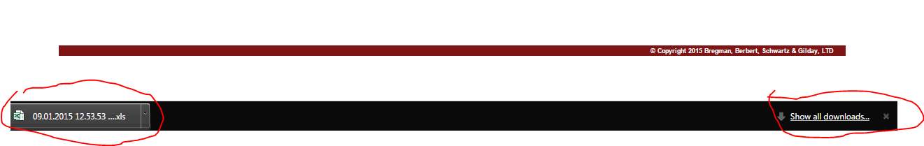

Move that file from the download area to the EFiling environment by clicking on Show All Downloads, then click on Show in Folder on the correct file.

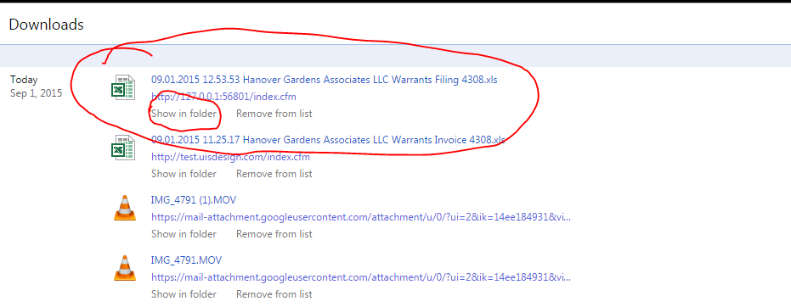

Then right-click on the correct file (based on name, and date the file was created).



Select copy, then navigate to your Helper area, right click, and select Paste. The result is shown below. Take the time to delete any older helper files from that directory, to prevent confusion.

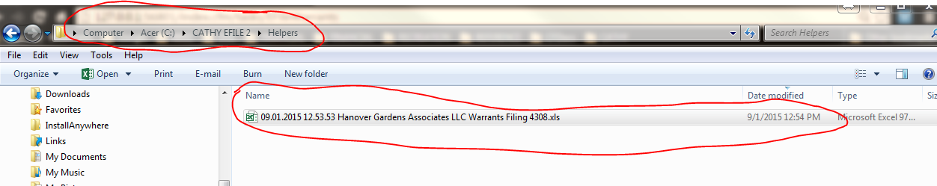

# Step W1 – Rename Signed Warrants from Scanner

* Go to your Desktop. Use the Windows key at the bottom right of your **Windows Taskbar** at the bottom of your screen to do this (may be hard to see). When you are “on your desktop”, you will see the icons you have put there.

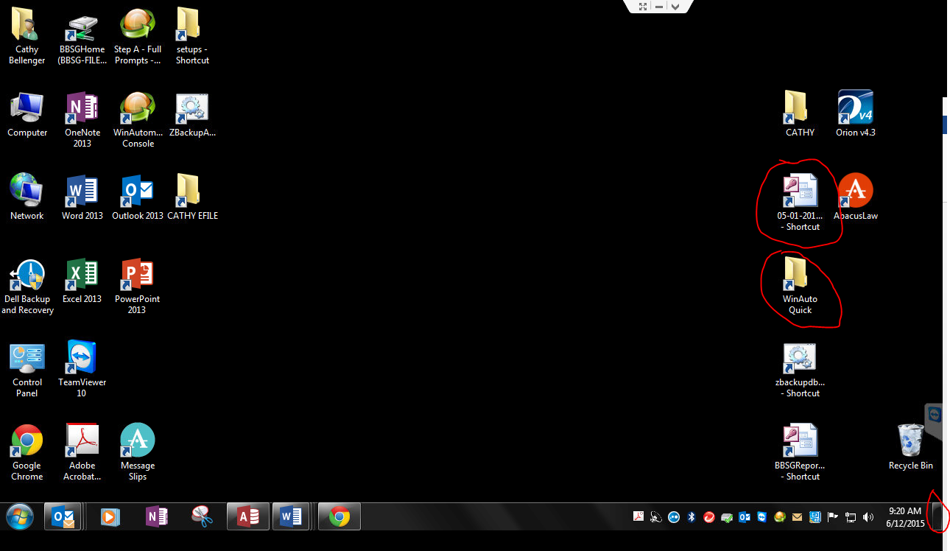

* Right Click on WinAutoQuick
* Select Open.
* Right-click the “Step W1” program
* Select Open.

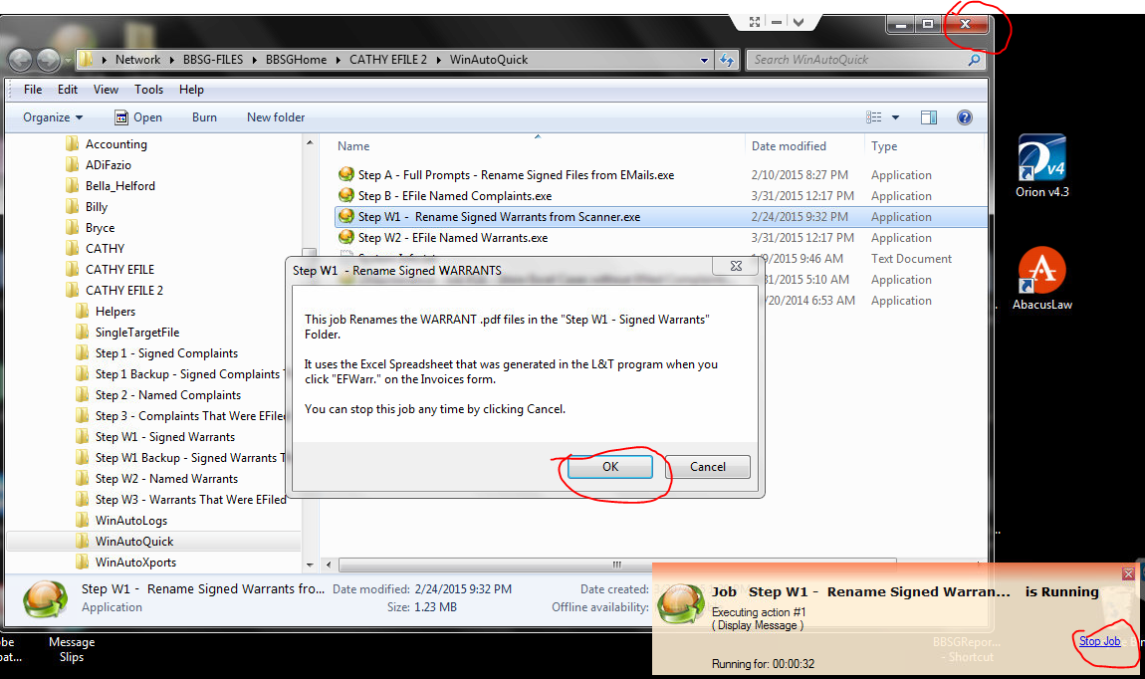

* **Close** the WinAutoQuick Explorer Window that you just opened, since you don’t need it any more. Typically you close a window by using the red X at the top right of the window.

Note that there is a small window in the lower right, with a link to stop this Step W1 job at any time. You can click Stop Job if the process described below “hangs”.

* Click OK in the Rename Signed Warrants Message Box above.
* Enter your name (you must be registered with the system), so that the following file locations are correct. Use “Cathy” on Cathy’s machine.
* Click OK

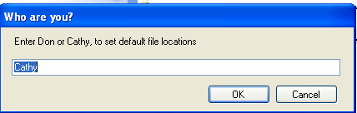

* Click OK to 3 file locations
* ***Left***-click the Helper Excel File ***ONCE*** you made in a previous step, e.g. “09/01.2015 12.53.53 Hanover Gardens Associates LLC Warrants Filing 4308.xlsx”. (You will automatically already be in the proper folder: F:\CATHY EFILE2\Helpers). You will see the name repeated in the File name: text box.
* Click Open
* WAIT (about 10 seconds)

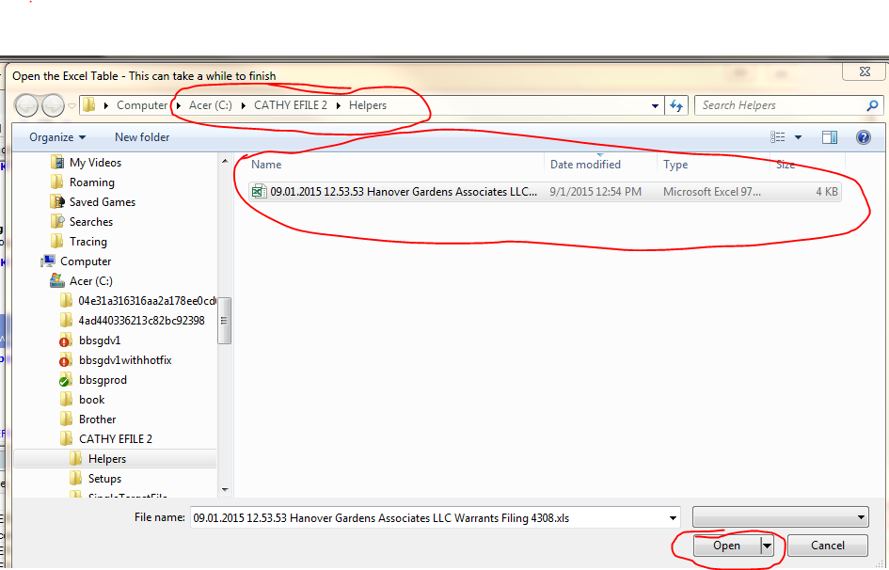

* This Step W1 routine brings up each case that is in the Excel Helper file.
* For each Warrant
* Type in the case number (“Case No”) from the document. It is on the right side of the Warrant under the Property Title. Note: the case numbers will not show up in order.
* Click OK. If you type the number incorrectly, you will get a notice. If you type the number correctly, you get a Match! Notice.

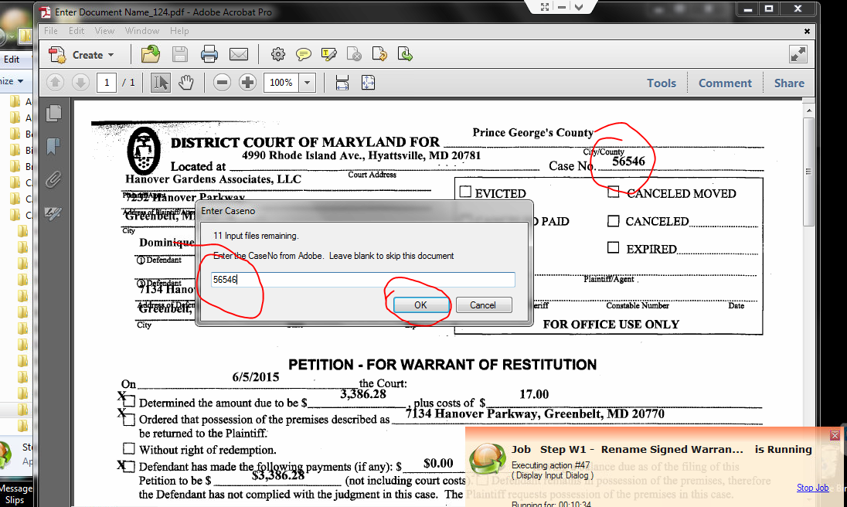

* Verify that the names are the same between the document, and the Match! Message (below), and click Yes.
* If you see a problem, you can click No, and fix things later.
* If things just “hang”,
  + Click “Stop Job” in the small window at the bottom right of your screen.
  + Start again with the steps in this “Step W1 – Renaming Signed Warrants” section of this document. You will pick up where you left off.

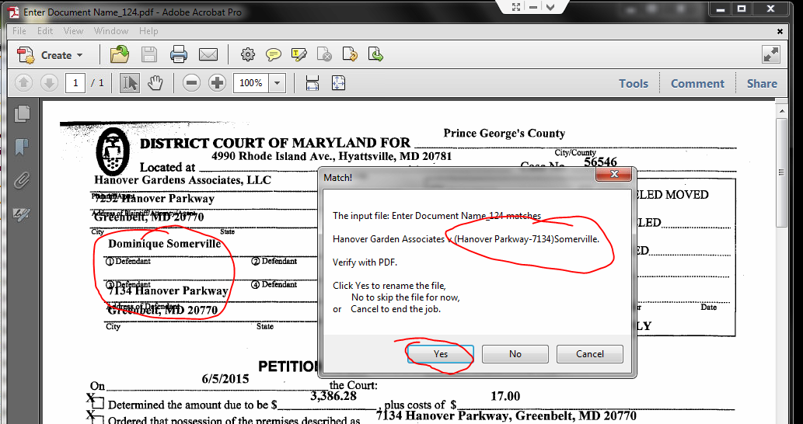

When you have finished renaming the files, you get the completion message.

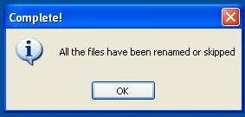

# Connect to EFile Express in the Internet Explorer Web Browser

* If unsure, verify your screen resolution. This will be correct on Cathy’s computer. **This system only runs at 1280 x 720, in Internet Explorer**, because the WinAutomation tool depends on the exact position of various buttons on the web pages.

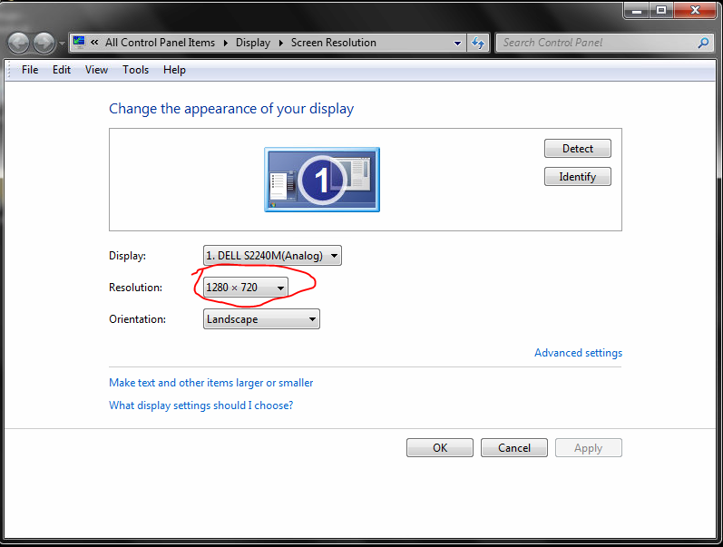

* Start Internet Explorer, from your Windows menu.
* Open the File Express Bookmark (in the Cathy’s folder on her bookmark toolbar), and log in. For reference, the bookmark is <https://secure.fileandservexpress.com/Home/Home.aspx?oldui=true>
* Click on here to log in.
* Login with credentials that Cathy has provided.

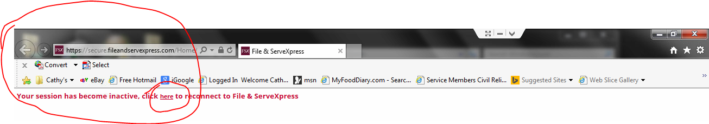

* Click on Filing & Service
* Click on Start a Transaction.
* Make sure this Internet Explorer is Maximized, using button next to the red X on the top right of the window.
* The Internet Explorer window should look exactly as shown below, or else the system may not work. Note there is a tool bar with “Convert” on it, and then the Bookmark Toolbar containing “Cathy’s” below that.

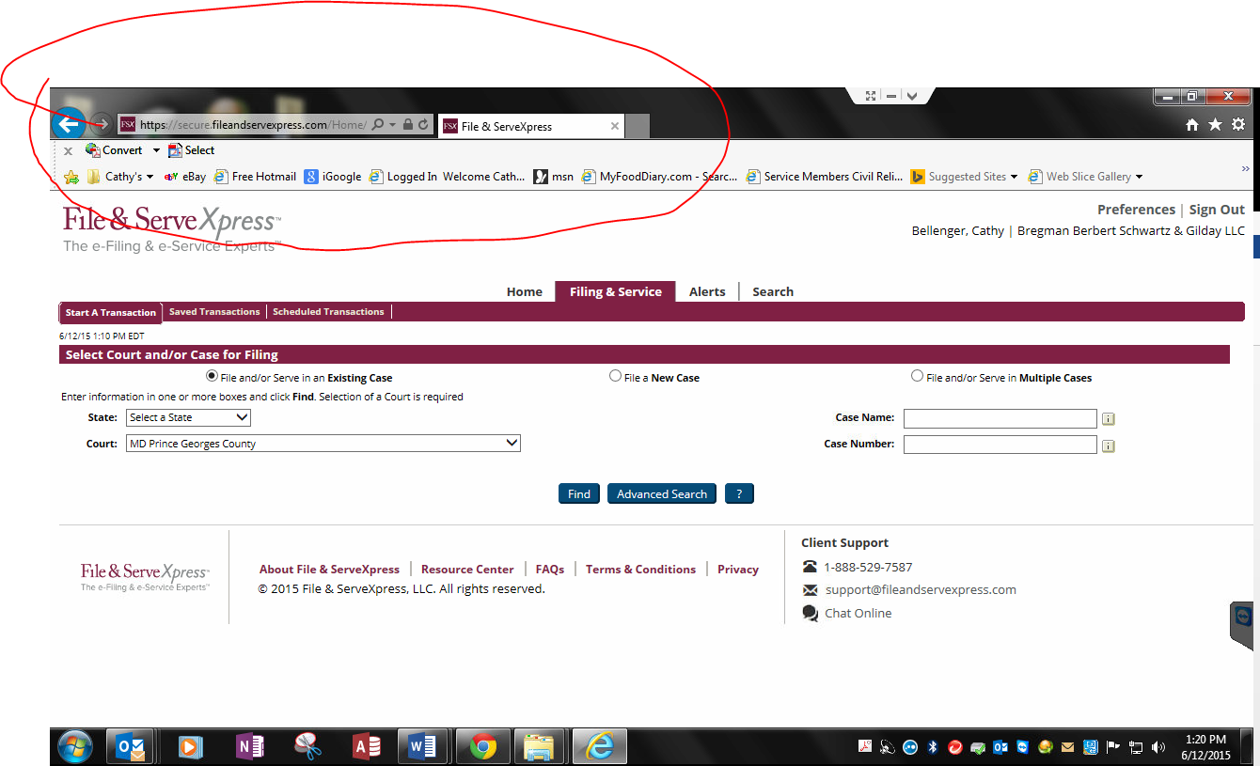

* Leave that window open while you do the next steps.

# Step W2 – Efile the Named Warrants

* Go to your desktop (see previous instructions about the Windows Desktop button on lower right of your Windows Task Bar).
* Decide what printer you are using, and set it up. If you are using Remote Printing, be sure it is checked in TeamViewer. If you are using a printer locally, be sure it is your “Windows Default Printer”.
* Right-click your desktop on the Shortcut to WinAutoQuick
* Select Open
* Right-click on Step W2 – Efile Named Warrants.exe
* Select Open.

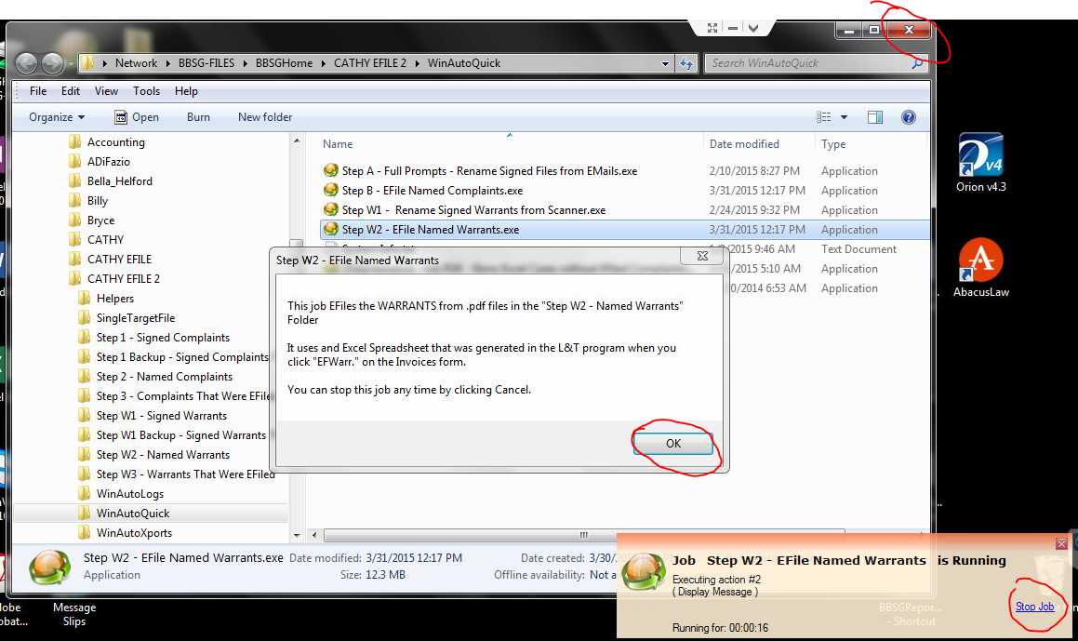

* Note that there is a Small window on the lower right, which contains a link that allows you to stop this “Step W2” job at any time. That window will always be there if the job is running.
* Close the larger, WinAutoQuick Window, that shows the various steps (red X on top right of Window)
* Click OK on the button below
* Enter your name (“Cathy”).
* Click OK
* Click OK 3 times to accept the next three file locations.
* Select the Excel Helper File you made for Step A. Do this by ***left***-clicking on the icon next to the filename, ***ONCE***. You will see the name repeated in the File name: text box.
* Click Open.



* Edit the date and time for submission. This might typically be at 4 AM or 4:15AM the following day.
* Click OK
* Enter the Plaintiff, properly capitalized. No commas.

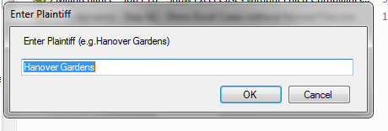

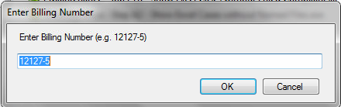 x

* Indicate whether you are printing “Remotely” (i.e. at Home). Select this if you are using TeamViewer from home.

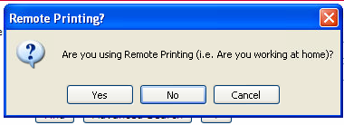

* Enter a Case Number Prefix. Be sure to include a dash at the end

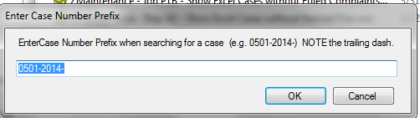

* Select Remote Printing if you are working from home

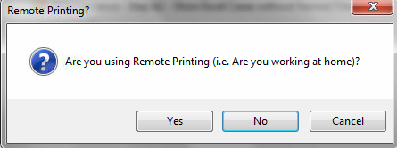

* Select Unattended Processing.
* Close the WinAutoQuick Window by clicking X on top right

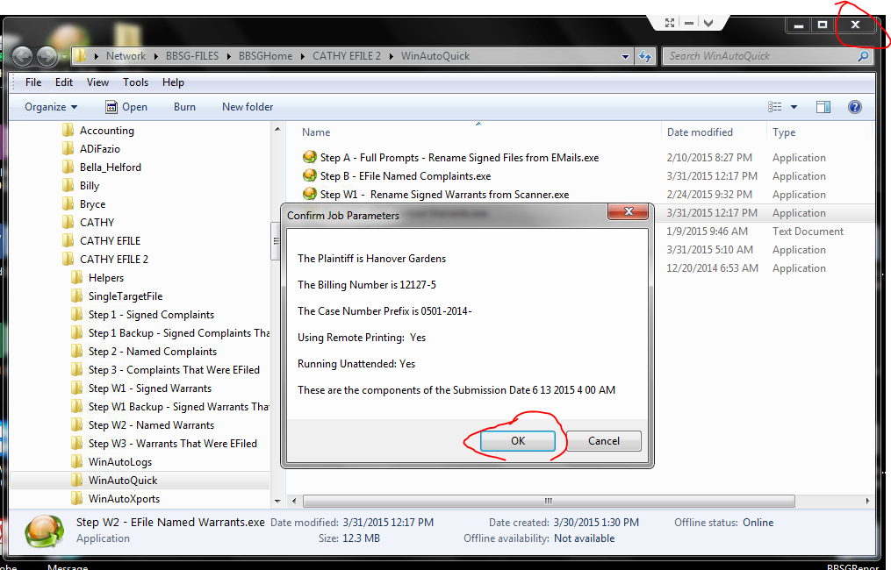

* Click OK.

Once you click OK, the Web process starts.

* WAIT (up to 30 seconds)
* Watch Internet Explorer as it processes a Warrant, and continue monitoring as it processes. This procedure is semi-delicate, with many moving parts, and may stop. After each case is filed, a receipt will be printed! The next case will start.
* Monitor the printer for **out of paper**, or **paper jams**.
* **It is very important that you give Cathy the stack of printed receipts from your printer, in order. She needs this for billing.**

**Once the job is complete, you get a confirmation message**

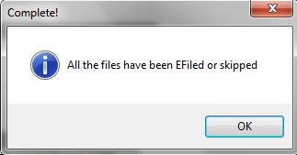

* Have fun.